

Digital Egypt Pioneers Initiative
DEPI

HR & Employee Analytics Project
Graduation Project

by
Omar Ahmed
Sohaila Saad
Osama Ashraf
Round 3 Data analysis, 2025

Supervised By
Jackie Abualeam
Project Overview

The HR Analytics Project aims to analyze and understand key workforce patterns within the organization using several data sources related to employees, performance, training, and demographics. The project’s primary goal is to transform raw, fragmented datasets into meaningful insights that support data-driven decision-making in areas such as employee satisfaction, turnover risk, performance distribution, and training utilization.
The project follows a complete analytics lifecycle starting from data exploration, cleaning, and preparation, passing through SQL analysis and data modeling, and ending with the development of an interactive Power BI dashboard. These insights are designed to help HR managers monitor workforce trends, identify performance gaps, evaluate training effectiveness, and support overall strategic planning.
This document section outlines the background, objectives, and analytical approach that guided the development of the final HR analytics solution.

Data Collection
1. Source of the Dataset
The dataset used in this project was provided as part of the Digital Egypt Pioneers Initiative (DEPI).
It represents a simulated HR system covering employee demographic information, job details, performance ratings, and attrition records.
All data was structured across five separate tables in the raw version.

2. Original Data Structure
The raw dataset initially consisted of five tables:
- Employee Table
  - Core table containing demographic details (age, gender, marital status), job information (department, role), salary, experience years, and employment details.
- PerformanceRating Table
  - Contains performance review results, manager ratings, job satisfaction, training opportunities, and work–life balance scores.
- EducationLevel Lookup Table
  - Maps numeric EducationLevelID → descriptive labels.
- SatisfiedLevel Lookup Table
  - Maps rating values for fields such as JobSatisfaction, WorkLifeBalance, EnvironmentSatisfaction, etc.
- RatingLevel Lookup Table
  - Provides text labels for performance scores used in the PerformanceRating table.

5. Final Prepared Data for Analysis

After cleaning and processing, the five original tables were transformed into two main analysis tables:
- Employee (Cleaned)
- PerformanceRating (Cleaned)
The lookup tables were integrated during cleaning, so their values became readable and analysis-ready.

Project Planning

1. Project Objectives
The primary objectives of this project were:
- To analyze workforce performance and identify key factors influencing employee attrition.
- To clean, structure, and model the dataset in a way that enables accurate and meaningful analysis.
- To build three interactive Power BI dashboards (Overview, Performance, Attrition) that support HR decision-making.
- To generate insights and recommendations that help improve employee retention, performance, and satisfaction.

2. Project Scope
- Data collection and dataset understanding
- Data cleaning and preprocessing
- Merging lookup tables into the main dataset
- Data modeling and relationship design
- Developing 25+ SQL analytical questions
- Creating three Power BI dashboards
- Producing insights and recommendations
- Preparing project documentation and reporting

3. Project Timeline

Phase |  | Duration
Data Collection | Understanding dataset structure | Week 1
Data Cleaning | Handling missing values, merging tables | Week 2&3
Data Modeling | Designing relationships & diagrams | Week 4
SQL Analysis | Writing & validating 25+ queries | Week 5&6
Dashboard Development | Overview, Performance, Attrition | Week 7&8
Reporting | Insights, recommendations, documentation | Week 9

4. Work Breakdown Structure (WBS)
The project was divided into these major components:
- Data Preparation
  - Reviewing dataset structure
  - Cleaning, merging, formatting
- Data Modeling
  - Creating star schema
  - Establishing relationships
- SQL Analysis
  - Writing analytical queries
  - Validating results
- Dashboard Development
  - Designing visuals
  - Applying consistent color themes
  - Creating filters & KPIs
- Reporting
  - Insights
  - Recommendations
  - Final documentation

5. Tools & Technologies Used
- Microsoft Excel – for data cleaning
- Python – for data merging and preprocessing
- SQL Server / MySQL – for data extraction and analytical queries
- Power BI – for dashboard design and visualization
- Word / Documentation Tools – for final report preparation

6. Deliverables
- Fully cleaned and structured dataset
- Data model & relationship diagram
- 25+ SQL analysis questions with results
- Three interactive dashboards
- Documentation including planning, modeling, insights, and recommendations

Data Cleaning
1. Cleaning employee.csv
- Duplicates: Checked for duplicate rows; none were found. The dataset contains 1,470 unique employees.
- Column assessment: Verified that all columns are relevant. Column names were updated to include spaces to make them more readable.
- Missing values: No missing values were found in the dataset.
- Data types: All columns have appropriate data types (e.g., numeric columns as integers or floats, dates as date objects).
- Appending external data: Descriptive Education Level information was added from EducationLevel.csv using the EducationLevelID as the key. The original numeric Education column was removed.
- Result: The cleaned and enhanced employee dataset was exported as df1.

2. Cleaning PerformanceRating.csv
The performance rating dataset contains 6,709 rows and 11 columns, including Employee ID, Review Date, satisfaction ratings, training opportunities, work-life balance, self-rating, and manager rating.
- Initial assessment: Cleaned column names for readability and checked for missing values.
- Observation: Employees are rated multiple times, so this dataset is analyzed independently of employee.csv
.

2.1 Merging Satisfaction Levels
- Objective: Replace numeric satisfaction columns with descriptive levels.
- Columns affected: Environment Satisfaction, Job Satisfaction, Relationship Satisfaction
- Source: SatisfiedLevel.csv
- Process: Numeric IDs were replaced with descriptive satisfaction levels. Original numeric columns were removed.
- Result: The satisfaction columns now contain descriptive levels instead of numeric IDs

2.2 Merging Rating Levels
- Objective: Replace selected numeric rating columns with descriptive levels.
- Columns affected: Work Life Balance, Self Rating, Manager Rating
- Source: RatingLevel.csv
- Process: Numeric IDs were replaced with descriptive rating levels. Original numeric columns were removed.
- Result: These rating columns now contain descriptive levels rather than numeric IDs.

2.3 Merging Rating Levels

• Objective: Replace the EducationLevelID in the Employee table with the descriptive education text.
• Source: EducationLevel.csv
• Process: Merged Employee with EducationLevel on EducationLevelID, replaced the coded values with the descriptive Education field, then removed the original ID column.
• Result: Employee table now contains the full Education description instead of numeric codes.

3. Summary
- The employee dataset (df1) is clean, readable, and enriched with descriptive education levels.
- The performance rating dataset (df2) contains descriptive satisfaction and rating levels, ready for analysis.
- Both datasets are consistent and prepared for further data analysis or modeling.

Data Modeling
Entity-Relationship Diagram (ERD)

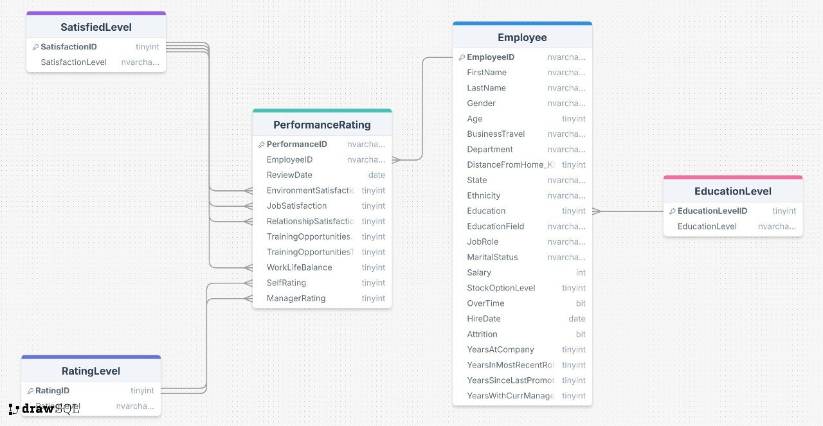

1. Employee Table (Dimension)
The Employee table serves as the core dimension table.
It contains stable employee-level information such as:
- EmployeeID (Primary Key)
- FirstName, LastName
- Gender, Age, MaritalStatus
- Education (after merging EducationLevel into this column)
- JobRole, Department
- MonthlyIncome, YearsAtCompany
- Attrition
- Other demographic and job-related attributes

The EducationLevel lookup table was merged into this table.
Numeric education codes were replaced with descriptive labels to simplify modeling and avoid unnecessary joins.

2. PerformanceRating Table (Fact)

The PerformanceRating table is the fact table storing periodic performance review metrics, including:
- RatingID (Primary Key)
- EmployeeID (Foreign Key)
- ReviewDate
- PerformanceRating
- ManagerRating
- SelfRating
- JobSatisfaction, EnvironmentSatisfaction
- WorkLifeBalance
- TrainingOpportunitiesTaken
- Other evaluation-related fields

Each employee can have multiple performance records over time —
One-to-Many relationship (Employee → PerformanceRating).

3. Lookup Tables (Reference)

Two lookup tables remain in the model to translate coded numeric values into readable labels:
- SatisfiedLevel — maps satisfaction-related codes (e.g., Job Satisfaction).
- RatingLevel — provides descriptive labels for rating scales used in performance metrics.
These tables are used only for mapping and do not store independent data.

4. Relationships
- Employee (1) → PerformanceRating (∞)
Main relationship used for filtering performance data by employee attributes.
- PerformanceRating → RatingLevel / SatisfiedLevel
Many-to-One relationships for descriptive lookup mapping.
The model follows a star-schema style, making it efficient for analysis and reporting.

5. Why EducationLevel Was Merged

The EducationLevel table contained only simple mappings.
So instead of keeping it as a separate lookup:
- Its descriptive values were merged directly into the Education column inside Employee.
- The numeric ID column was removed.
- This reduces joins, improves Power BI performance, and simplifies the entire model.

6. Advantages of This Modeling Approach
- Cleaner and simpler model with fewer tables
- Faster queries and better Power BI performance
- Descriptive values readily available without extra joins
- Suitable for aggregations, departmental analysis, time trend evaluations, and attrition insights

7. Power BI Notes
To ensure proper filtering and calculations:
- Set the relationship direction as single-direction from Employee → PerformanceRating
- Define EmployeeID as PK in Employee and FK in PerformanceRating
- Create common measures such as:
Total Employees = DISTINCTCOUNT(Employee[EmployeeID])
Average Performance = AVERAGE(PerformanceRating[PerformanceRating])
Attrition Rate = DIVIDE(CALCULATE(COUNTROWS(Employee), Employee[Attrition] = "Yes"), [Total Employees])

8. Data Quality Check
Before final modeling:
- Ensure all EmployeeIDs match across tables
- Remove duplicates
- Validate lookup mapping accuracy

Stakeholder Analysis

- 1. HR Department
The HR team is the main stakeholder. They would use the analysis to understand employee performance, satisfaction, training needs, and retention risks. Their goal is to improve workforce planning and develop better HR strategies.

- 2. Top Management / Executives
Senior leaders are interested in high-level insights that support decision-making. They want to know how employee performance and satisfaction affect productivity and how improving HR policies could increase overall organizational efficiency.

- 3. Team Managers / Supervisors
Managers would use the results to track their teams’ performance, identify skill gaps, and understand what factors drive employee satisfaction or dissatisfaction within their departments.

- 4. Employees (Indirect Stakeholders)
Employees are not directly involved in the analysis, but the outcomes affect them—such as improved training programs, better management practices, and enhanced workplace conditions.

- 5. Data & IT Department
The IT team would be responsible for providing access to the datasets, ensuring data quality, and maintaining any systems used to store or manage employee data.

